Unit Search

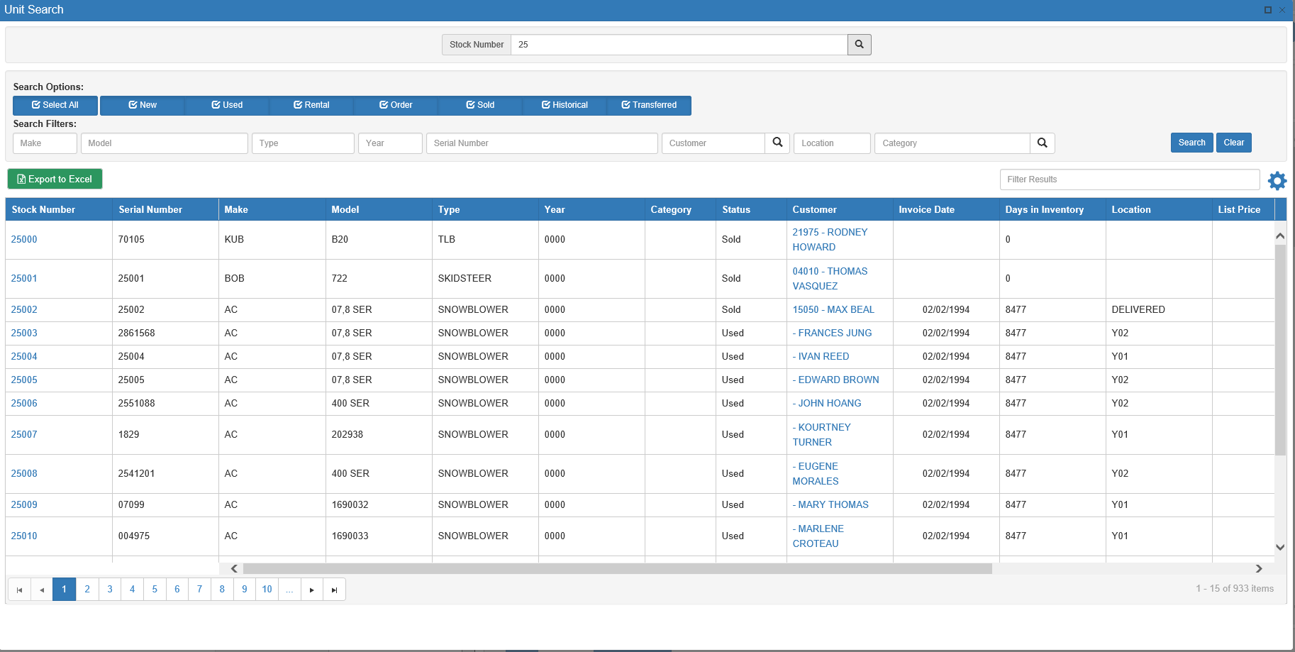

This particular Unit Search screen is present in Unit Inquiry (UI) and Unit Maintenance (UM). It generally operates like other Unit Searches in the system, but has a few additional features as well.

Field Definitions:

Stock Number: You may enter all or part of the stock number in this field.

Search Options: You may use these checkboxes to search for units of a particular status. You must choose at least one search option to begin a search.

- Select All: Click this to search ALL unit statuses for your desired result.
- New: Click this to select all NEW units in your inventory.
- Used: Click this to select all USED units in your inventory.
- Rental: Click this to select all RENTAL units in your inventory (Rental Package ONLY).
- Order: Click this to select all units ON ORDER.
- Sold: Click this to select all SOLD units.
- Historical: Click this to select all HISTORICAL units (entered from ROM or Customer Equipment)
- Transferred: Click this to select all units that have been TRANSFERRED out to another dealer.

Search Filters: You can add info to any of the following fields to refine the search.

Make: You may enter all or part of the make in this field.

Model: You may enter all or part of the model number in this field.

Type: You may enter all or part of the type in this field.

Year: You may enter all or part of the model year in this field.

Serial #: You may enter all or part of the serial number in this field.

Customer: When the unit is sold or transferred, the system records the name of the purchaser or customer in this field. You can enter the customer number or look it up by typing in a portion of the customer’s name.

Location: You can search by the physical location of the unit by typing in all or part of the value in the Location field on the Unit Master.

Customer: When the unit is sold or transferred, the system records the name of the purchaser or customer in this field. You can enter the customer number, or look it up by typing in a portion of the customer’s name and clicking the 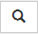 icon to open the Customer Search window (see below). You can also simply click the search icon without entering information to open a blank window and search from there.

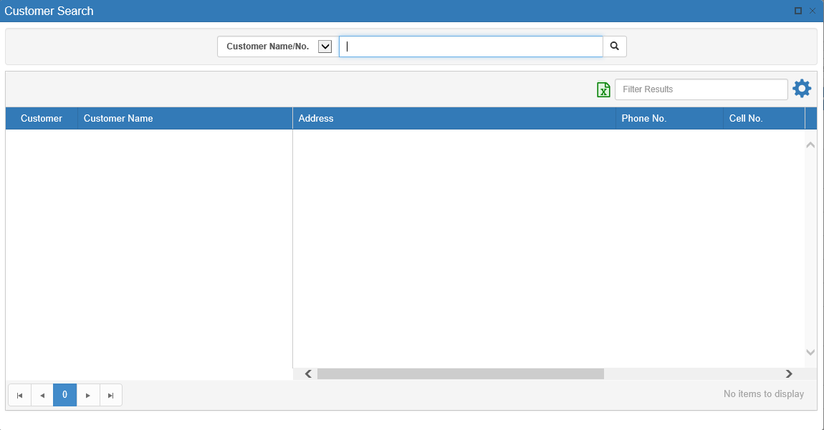

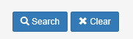

Search/Clear: Once you have entered all you search criteria, click on the Search button to see the results in the grid. To clear your search choices, click the Clear button.

Results Grid:

Sort Features: These features attached to the results listing grid let you sort through your results to find the entry you want.

Page Numbers: Use the page numbers at the bottom of the window to jump between pages.

Sortable Headers: Click on the arrow on the right side of the column headers to view further sort options.

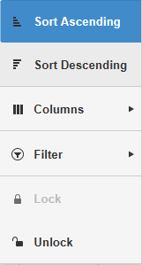

- Sort Ascending: Click this option to sort the results in ascending order by the column’s content. For example, if you click “Sort Ascending” under the Stock Number header, then the results will sort in ascending order by stock number. You can also perform this sort by clicking the column header once.
- Sort Descending: Click this option to sort the results in descending order by the column’s content. For example, if you click “Sort Descending” under the Stock Number header, then the results will sort in descending order by stock number. You can also perform this sort by clicking the column header.
  - Click the header twice from when the search window first opens or if the results have been sorted by a different column.
  - Click the header once if the results are already sorted in ascending order by that column’s content.
- Columns: Use this checklist to determine which columns you want to view.
  - Removing the check from a box will automatically remove the column from the results grid.
  - Checking a box will automatically add the column to the grid.
- Filter: This option allows you to filter your search results in greater detail using the data in that specific column. Use the drop-down menus to set how you want the results to filter.
- Lock: Clicking “Lock” fixes the column in its location. NOTE: This feature does not appear for all columns.
- Unlock: Clicking “Unlock” allows you to switch the column’s position in the grid order. NOTE: This feature does not appear for all columns.

Filter Bar: Use the Filter Bar in the upper right-hand corner to further narrow down the results. Type in further search criteria, and the results will update to reflect it.

Other Features:

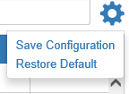

Save Configuration/Restore Search: Click this blue gear icon to access the option to either save the current search configuration or reset the search to its default settings.

Export to Excel: Click this button to export the search results into Microsoft Excel.

